Under this assignment we were asked to create a paginated report and for that we were required to use **POWER BI REPORT BUILDER.** As the file picks the data from the SQL Server I am unable to provide the access for the file because as soon the file is opening it shows an error for the data. Therefore, I have attached the report exported from the **POWER BI REPORT BUILDER** and along with that I have also attached screenshot from the paginated report for your reference.

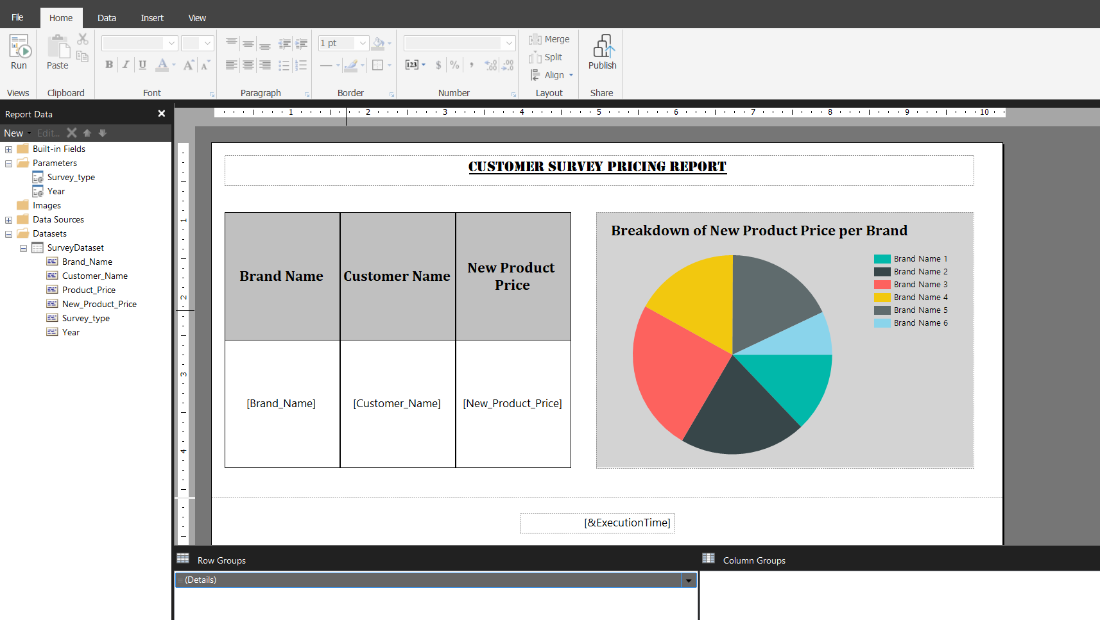

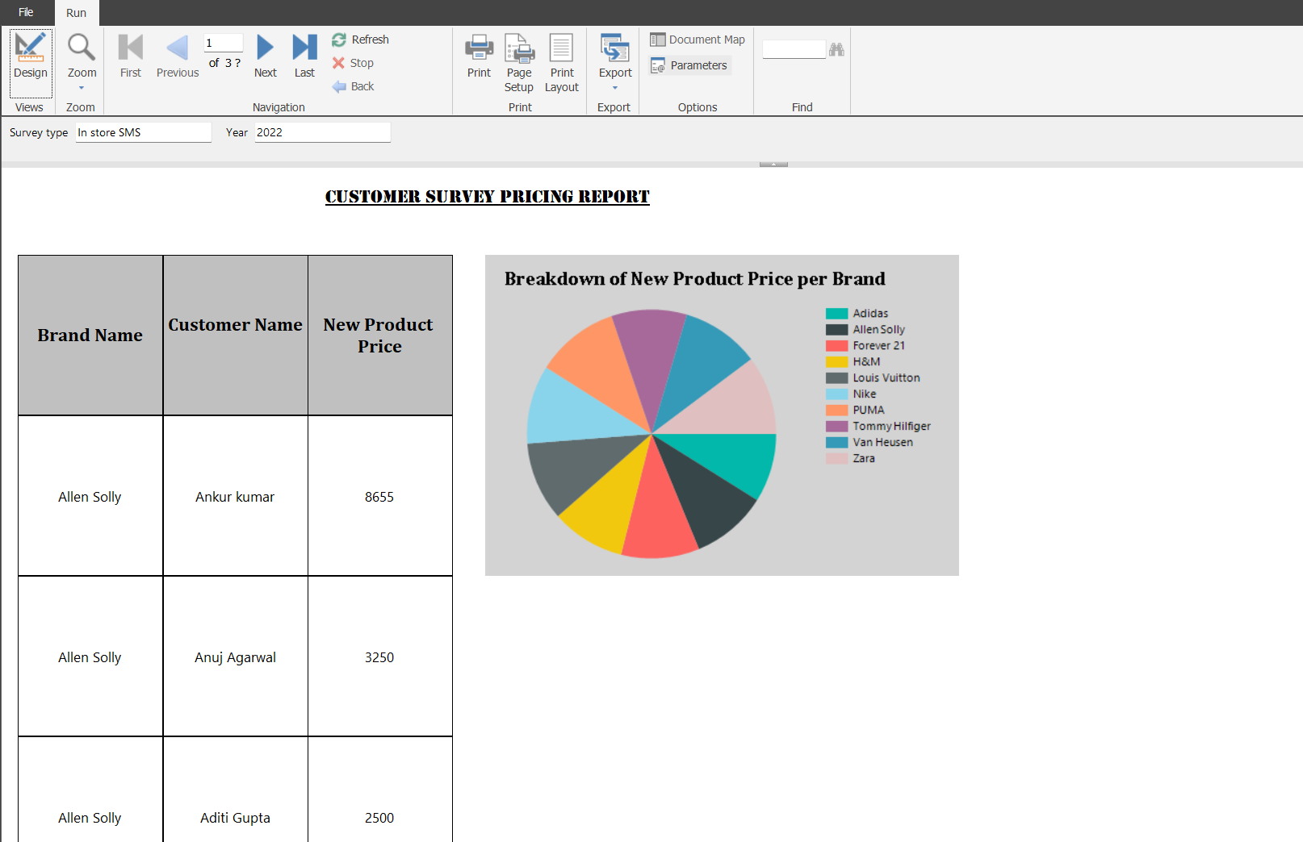

This is the output the report shows once we hit the **RUN button.** For the access to the report the credentials are:

**SURVEY TYPE**: In Store SMS

**YEAR**: 2022. The report exported from the **POWER BI REPORT BUILDER**

|  |  |  |  |  |
| --- | --- | --- | --- | --- |
|  |  |  |  |  |
|  | |  | | --- | | Customer Survey Pricing Report | | | |  |
|  |  |  |  |  |
|  |  |  |  |  |
|  |  |  |  |
|  |  |  |  |  |

|  |  |  |
| --- | --- | --- |
| **Brand Name** | **Customer Name** | **New Product Price** |
| Allen Solly | Ankur kumar | 8655 |
| Allen Solly | Anuj Agarwal | 3250 |
| Allen Solly | Aditi Gupta | 2500 |
| Allen Solly | Deepti | 6160 |
| Allen Solly | Rajat Bhatt | 3175 |
| Allen Solly | D K Gupta | 6905 |
| Allen Solly | Pallavi Panwar | 2745 |
| Allen Solly | Mayank Agrawal | 3655 |
| Allen Solly | Arun Singh | 2890 |
| Allen Solly | Keya Sengupta | 6645 |
| Allen Solly | Siddharth Chhajlany | 1785 |
| Allen Solly | Abisha patel | 2540 |
| Allen Solly | Janhavi | 2155 |
| Allen Solly | Nikita Kanodia | 3295 |
| Allen Solly | Rashmi Kaushal | 6700 |
| Allen Solly | Avni Aggarwal | 2630 |
| Allen Solly | Kaushal Seth | 4975 |
| Allen Solly | Parul | 5510 |
| Allen Solly | Rajat Arora | 8550 |
| Allen Solly | Zoya | 4335 |
| Allen Solly | Siddhant Sharma | 4140 |
| Allen Solly | Janani Karthik | 2860 |
| Allen Solly | Mukul Garg | 8670 |
| Allen Solly | Rajat Gupta | 1985 |
| Allen Solly | Baljeet | 3370 |
| Allen Solly | Mandygrover | 4220 |
| Allen Solly | Pavan Dagar | 3465 |
| Allen Solly | Pavan Dowari | 4710 |
| Allen Solly | Titiksha | 3125 |
| Allen Solly | Priya | 3450 |
| Allen Solly | Pavan Gowda | 6470 |
| Allen Solly | Akshra Yadav | 3820 |
| Allen Solly | Abhikaam Dixit | 8795 |
| Allen Solly | Arvind | 6890 |
| Allen Solly | Surya Ranjan Singh | 4435 |
| Allen Solly | R Kumaravelu | 6180 |
| Allen Solly | Navjot | 8425 |
| Allen Solly | Ankit Goswami | 3625 |
| Allen Solly | Arijit Banerjee | 4760 |
| Allen Solly | Anjan | 8425 |
| Allen Solly | Zehra Khan | 6440 |
| Allen Solly | Dipak | 3270 |
| Allen Solly | Prashant | 8730 |
| Allen Solly | Rajat Dutta | 4075 |
| Allen Solly | neha mahapatra | 1820 |
| Allen Solly | GAURAV verma | 4980 |
| Allen Solly | Damyant Singh | 2850 |
| Allen Solly | Vinay Rathi | 5070 |
| Allen Solly | Prashant Kumar | 5240 |
| Allen Solly | Jasleen | 3665 |
| Forever 21 | Tushar | 3215 |
| Forever 21 | Abhishek Bindal | 8610 |
| Forever 21 | neelam phadke | 7680 |
| Forever 21 | Mohiraj singh | 4490 |
| Forever 21 | Ayush Garg | 4200 |
| Forever 21 | Pranita | 2770 |
| Forever 21 | Ayush Srivastava | 3900 |
| Forever 21 | Mohit Srivastav | 5975 |
| Forever 21 | Deepa Newar | 3380 |
| Forever 21 | Arjun Kumar | 4350 |
| Forever 21 | Rahul Gaur | 4765 |
| Forever 21 | Sonali Khanna | 5710 |
| Forever 21 | Sandeep gill | 2770 |
| Forever 21 | Paban Dowari | 3835 |
| Forever 21 | Kunal Chopra | 3420 |
| Forever 21 | Akshra | 5125 |
| Forever 21 | Akshay Gawri | 4515 |
| Forever 21 | Ashish Yadav | 3945 |
| Forever 21 | Katheeja | 6510 |
| Forever 21 | Sakshi Narang | 8880 |
| Forever 21 | Maniish Mishra | 2905 |
| Forever 21 | Khushboo | 3830 |
| Forever 21 | Aakanksha | 6600 |
| Forever 21 | Harsh | 4775 |
| Forever 21 | Tanjot Singh | 3990 |
| Forever 21 | Tanjot Verma | 1520 |
| Forever 21 | Riya | 5745 |
| Forever 21 | Tanjot | 6285 |
| Forever 21 | Vishnu Soni kumar | 2180 |
| Forever 21 | Aditya hundia | 7965 |
| Forever 21 | Manoj | 2250 |
| Forever 21 | Mohammed Jithin | 3240 |
| Forever 21 | Siphat | 2405 |
| Forever 21 | Nisha Jenifer | 2985 |
| Forever 21 | Malovika Roy | 4440 |
| Forever 21 | Shreyans Pagaria | 2920 |
| Forever 21 | Komal mal | 6015 |
| Forever 21 | Kuku | 3645 |
| Forever 21 | Kapil | 4735 |
| Forever 21 | Tanishq Bindra | 4225 |
| Forever 21 | Rahul | 7480 |
| Forever 21 | Jehangir Ready | 6370 |
| Forever 21 | Saad khan | 4500 |
| Forever 21 | Aman Agarwal | 7025 |
| Forever 21 | Varun Tyagi | 5745 |
| Forever 21 | Vipin Raina | 5910 |
| Forever 21 | Varun Ahlowalia | 7675 |
| Forever 21 | Kamal Bamba | 6990 |
| Forever 21 | Santhosh Malleshwara | 4715 |
| Forever 21 | Navjot Hanspal | 6770 |
| H&M | Shivam agrawal | 4620 |
| H&M | Sahil Goel | 3615 |
| H&M | Ashish Dagar | 1620 |
| H&M | Samar Khan | 2600 |
| H&M | Arjun Verma | 5895 |
| H&M | Jonty Vij | 5930 |
| H&M | Gavin Dcunha | 2725 |
| H&M | Puja | 1505 |
| H&M | Srivatsa Prakhya | 2215 |
| H&M | Khushi Munjal | 5935 |
| H&M | Gaurab | 5020 |
| H&M | Gaurav Garg | 3245 |
| H&M | Gaurav Yadav | 8750 |
| H&M | Gaurav Sharma | 6355 |
| H&M | Akash | 5700 |
| H&M | Rohan | 4160 |
| H&M | Devika | 8415 |
| H&M | Rakesh Bansal | 3320 |
| H&M | Tisha Saraf | 2410 |
| H&M | Aatif Mohiudin Lone | 3195 |
| H&M | aditi chansoria | 4360 |
| H&M | Rashmi Gourisaria | 4490 |
| H&M | Harshit Agarwal | 8475 |
| H&M | P Vishwa Prasad Reddy | 7060 |
| H&M | Rajan Chhabra | 5545 |
| H&M | Radhika Gattani | 2490 |
| H&M | Gaurav Goyal | 8840 |
| H&M | Chandan Bhgat | 4930 |
| H&M | Deepak patiyal | 1995 |
| H&M | Tenzin Norbu | 6580 |
| H&M | Anuradha kumari | 8605 |
| H&M | Anuradha | 2215 |
| H&M | Anupriya | 5480 |
| H&M | Anu | 2975 |
| H&M | Kapil garg | 2915 |
| H&M | Pratyush Choudhary | 2180 |
| H&M | Pooja Malik | 4615 |
| H&M | Komal mall | 5160 |
| H&M | Sneha Goyal | 2730 |
| H&M | Arshdeep Singh | 4375 |
| H&M | Writuparna Ghose | 3985 |
| H&M | Chirag | 3020 |
| H&M | Yashvardhan Verma | 2420 |
| H&M | Pundrik | 6210 |
| H&M | Dilpreet Singh | 3350 |
| H&M | Kitanbir Singh | 2865 |
| H&M | Nikita Agarwal | 5470 |
| H&M | Sachin Agarwal | 7030 |
| H&M | Vedant Agrawal | 6825 |
| H&M | MD Danish | 5605 |
| Van Heusen | Yash Yadav | 5160 |
| Van Heusen | Ravina Bajaj | 4575 |
| Van Heusen | Jaikishan | 5405 |
| Van Heusen | Abhinav Kapur | 4715 |
| Van Heusen | Radhika | 6540 |
| Van Heusen | Tejal Mehta | 3435 |
| Van Heusen | Heena Khan | 3830 |
| Van Heusen | Sana | 2535 |
| Van Heusen | Satyenra Gandhi | 3160 |
| Van Heusen | RAVNEET KAUR | 4015 |
| Van Heusen | Rajeev Arora | 8800 |
| Van Heusen | Siddharth Jain | 7305 |
| Van Heusen | Pankaj Joshi | 5295 |
| Van Heusen | Rajesh | 6555 |
| Van Heusen | Eshaan | 4010 |
| Van Heusen | Punita Bhatia | 5995 |
| Van Heusen | Gagan brar | 4330 |
| Van Heusen | DHANANJAY KHOT | 7975 |
| Van Heusen | Pawan Agrawal | 5825 |
| Van Heusen | Yash Katra | 2900 |
| Van Heusen | Mani singh | 4125 |
| Van Heusen | Ayushi | 3635 |
| Van Heusen | Sanjay Kumar Yadav | 6295 |
| Van Heusen | Shalini dagar | 2975 |
| Van Heusen | PANKAJ BABBAR | 6520 |
| Van Heusen | RISHAV DAS | 6150 |
| Van Heusen | MANOJ DoGRA | 5355 |
| Van Heusen | Malavika G | 2580 |
| Van Heusen | Trilok | 1520 |
| Van Heusen | Poojan | 6185 |
| Van Heusen | Chetan Gujral | 6460 |
| Van Heusen | Lakhwinder | 4820 |
| Van Heusen | Akshay | 3420 |
| Van Heusen | Deepak | 5540 |
| Van Heusen | AKHIL NATH | 4060 |
| Van Heusen | Benjam | 3790 |
| Van Heusen | Pratima Morey | 6625 |
| Van Heusen | Nishi Agarwal | 6345 |
| Van Heusen | Mahesh | 5990 |
| Van Heusen | Mayank bajaj | 2835 |
| Van Heusen | Jennifer Bahuguna | 6585 |
| Van Heusen | Kritika Malhotra | 3100 |
| Van Heusen | Ashish | 2655 |
| Van Heusen | KANISHK | 4145 |
| Van Heusen | Revansidda | 5150 |
| Van Heusen | Bharat | 3945 |
| Van Heusen | Bhavin A Upadhyay | 5315 |
| Van Heusen | N R HARIBABU | 3795 |
| Van Heusen | Chethan | 5305 |
| Van Heusen | Venkat | 6480 |
| Nike | Kalash | 6495 |
| Nike | N HARIBABU | 3435 |
| Nike | Mohit | 4905 |
| Nike | Rahul Garg | 4850 |
| Nike | Fredy John | 3290 |
| Nike | Sunil | 3225 |
| Nike | Rohit Dobriyal | 4320 |
| Nike | Keerthan Kumar Y K | 7385 |
| Nike | Shallu verma | 3520 |
| Nike | Dishant Choudhary | 5620 |
| Nike | Rahul Mohan | 5955 |
| Nike | Yanira | 4865 |
| Nike | Vaibhav Jain | 6145 |
| Nike | Tanisha | 4085 |
| Nike | Shanky | 4150 |
| Nike | Adesh Vishavjeet Singh | 6430 |
| Nike | pradipta sarkar | 4860 |
| Nike | Utkarsh handa | 3770 |
| Nike | Sachin | 1840 |
| Nike | Ankur | 6520 |
| Nike | Rahul Singh | 3900 |
| Nike | Rohan singh | 3865 |
| Nike | Rashi Agrawal | 3590 |
| Nike | Jyotsna | 2585 |
| Nike | Pankaj Singh | 4325 |
| Nike | Vaibhav | 1955 |
| Nike | Mohit Aggrawal | 5125 |
| Nike | Rahan Garg | 2715 |
| Nike | Fredy | 5330 |
| Nike | Sunil singh | 8615 |
| Nike | Praneet | 5770 |
| Nike | Vaibhav Gupta | 4440 |
| Nike | Himanshu Kohli | 2715 |
| Nike | Immamuddin | 5685 |
| Nike | Sidhant Sundrani | 4315 |
| Nike | Rashesh | 4490 |
| Nike | Taru | 6125 |
| Nike | Kunal singh | 2540 |
| Nike | Shreya agarwal | 7865 |
| Nike | Preeti | 7910 |
| Nike | Bhavini Malhotra | 3765 |
| Nike | Yash | 3935 |
| Nike | Manyaa | 7650 |
| Nike | Anand Kirtikar | 6855 |
| Nike | pramod | 4690 |
| Nike | Mahesh Dagar | 8755 |
| Nike | Ambika | 6765 |
| Nike | Jacob | 2530 |
| Nike | Rahul Aggarwal | 6430 |
| Nike | Rahul Agarwal | 3920 |
| Adidas | Shubhkaran | 4390 |
| Adidas | Anchit Jain | 6605 |
| Adidas | Nikhil Daman | 2985 |
| Adidas | Pooja Kumari | 6100 |
| Adidas | Sandeep Reddy | 3420 |
| Adidas | Pooja | 3520 |
| Adidas | Shubhal Goel | 5100 |
| Adidas | Rajat Jain | 1900 |
| Adidas | Mohd Sharief | 5285 |
| Adidas | Gourav | 5960 |
| Adidas | Shruti Chaudhary | 2840 |
| Adidas | Aanchal | 1645 |
| Adidas | Sanjayjain | 7715 |
| Adidas | SHRAYA JAIN | 5860 |
| Adidas | Soumil sardana | 3950 |
| Adidas | Sumit Dagar | 4125 |
| Adidas | Yogesh | 2925 |
| Adidas | Ankush | 4610 |
| Adidas | Sachin srivastava | 4595 |
| Adidas | Siddharth Yadav | 4465 |
| Adidas | Mehak Raizada | 3510 |
| Adidas | Pavan Vadde | 2085 |
| Adidas | Ronak Shah | 5755 |
| Adidas | Shikha Jain | 3960 |
| Adidas | Akriti Gupta | 5010 |
| Adidas | Prashant Surywanshi | 4170 |
| Adidas | Pragnesh patel | 4910 |
| Adidas | Niharika Govda | 2715 |
| Adidas | Rajarathinam | 6495 |
| Adidas | Almas Manekia | 2615 |
| Adidas | Maulik | 3395 |
| Adidas | Heena | 4750 |
| Adidas | Shitij Anand | 2790 |
| Adidas | K Chandra Obul Reddy | 3925 |
| Adidas | Lokesh Piplani | 4615 |
| Adidas | Ankit Das | 6490 |
| Adidas | Arpit | 5845 |
| Adidas | Shaganjeet | 4365 |
| Adidas | Shobhit Aggarwal | 2660 |
| Adidas | Konishka | 2985 |
| Adidas | Mayank Tiwari | 3640 |
| Adidas | Purnima | 2115 |
| Adidas | Deepti Yadav | 7975 |
| Adidas | Vicky | 1905 |
| Adidas | Abhay | 5550 |
| Adidas | Pallavi Barua | 3815 |
| Adidas | tanya | 4130 |
| Adidas | Tania | 3100 |
| Adidas | Piyush Marodia | 2345 |
| Adidas | Chetan Bhagat | 8330 |
| Zara | Ankur Kapania | 1960 |
| Zara | Shivani Reddy | 5805 |
| Zara | Nancy | 7020 |
| Zara | Karen Nazareth | 5860 |
| Zara | Aryan Agarwal | 3155 |
| Zara | Rajinder Malik | 2925 |
| Zara | Arihant | 6300 |
| Zara | Swapnil Mody | 5585 |
| Zara | Shashidhar | 6270 |
| Zara | Sumit Sachdeva | 4190 |
| Zara | Reya | 5865 |
| Zara | Reema | 6200 |
| Zara | Reeta | 8275 |
| Zara | Shikha | 6265 |
| Zara | Sourabh | 2435 |
| Zara | Bala | 3970 |
| Zara | Geet Vats | 8950 |
| Zara | Samir | 5620 |
| Zara | Prabhjot | 2245 |
| Zara | Ayushi Agarwal | 6800 |
| Zara | Nirmal Patel | 6210 |
| Zara | Pooja Jain | 4205 |
| Zara | Sumedha | 4250 |
| Zara | DHANANJAY S KHOT | 2840 |
| Zara | Neetu | 7455 |
| Zara | Mayank | 3460 |
| Zara | Siddharth | 1655 |
| Zara | Devendra Madhyani | 2460 |
| Zara | Devendra Das | 4675 |
| Zara | Chandan Bhagat | 7905 |
| Zara | Ahana | 6725 |
| Zara | Anshul Jain | 2015 |
| Zara | Anagh Narayan Khoday | 5600 |
| Zara | Gurpal Singh | 2380 |
| Zara | Ashutosh | 4475 |
| Zara | Saiesh Paigankar | 2755 |
| Zara | Nancy Jain | 6785 |
| Zara | Umang | 4360 |
| Zara | Nisha Jenifer Menezes | 3565 |
| Zara | Pankaj Agarwal | 3960 |
| Zara | Kanika makhija | 5620 |
| Zara | Harinder Mann | 5905 |
| Zara | aamir | 3000 |
| Zara | Akhil | 3295 |
| Zara | Vishal | 7760 |
| Zara | Kundika sharma | 6525 |
| Zara | Payal dogra | 7040 |
| Zara | Snehal Goyal | 3650 |
| Zara | KARAN | 3085 |
| Zara | SHRAYESH JAIN | 6955 |
| Louis Vuitton | Sakib Khan | 5770 |
| Louis Vuitton | Meenal Kumar | 5820 |
| Louis Vuitton | Meenal | 2520 |
| Louis Vuitton | Tina Kumari | 2975 |
| Louis Vuitton | Meena | 5915 |
| Louis Vuitton | Paras Kakkar | 3790 |
| Louis Vuitton | Priya singh | 4425 |
| Louis Vuitton | Tony | 4455 |
| Louis Vuitton | Shreya dagar | 7535 |
| Louis Vuitton | Kavin Ohri | 3610 |
| Louis Vuitton | Rahul verma | 4975 |
| Louis Vuitton | Rajni Vadadoriya | 4145 |
| Louis Vuitton | Ravdeep Singh Sandhu | 2695 |
| Louis Vuitton | Tilu | 5800 |
| Louis Vuitton | Ajay nagar | 4165 |
| Louis Vuitton | Vijay kumar | 2330 |
| Louis Vuitton | Dev | 4035 |
| Louis Vuitton | Neha kakkar | 6965 |
| Louis Vuitton | Aditya Arora | 2215 |
| Louis Vuitton | Ishika jain | 2585 |
| Louis Vuitton | Preeti Sukhwani | 4390 |
| Louis Vuitton | Jasil Nk | 3335 |
| Louis Vuitton | Vimal | 3450 |
| Louis Vuitton | Nikhil khari | 3395 |
| Louis Vuitton | Rahul Ahuja | 8855 |
| Louis Vuitton | Sarita Jain | 7610 |
| Louis Vuitton | Nivedita Vaishnav | 6250 |
| Louis Vuitton | Rahul hari | 6755 |
| Louis Vuitton | Naveen | 3320 |
| Louis Vuitton | Mohit Srivastava | 4490 |
| Louis Vuitton | Sowmya | 8575 |
| Louis Vuitton | Mayank panchal | 3190 |
| Louis Vuitton | Amandeep Singh | 4280 |
| Louis Vuitton | Papiya Ghosh | 8535 |
| Louis Vuitton | Udit Gadia | 6420 |
| Louis Vuitton | Palak | 1750 |
| Louis Vuitton | Sagar Takkar | 4825 |
| Louis Vuitton | Suyash goyal | 3460 |
| Louis Vuitton | Shabnam | 7455 |
| Louis Vuitton | Dhruv Kakkar | 3300 |
| Louis Vuitton | Ajey Padval | 5720 |
| Louis Vuitton | Abhishek Das | 1550 |
| Louis Vuitton | Navnidh Singh Chawla | 4040 |
| Louis Vuitton | Vinod Kumar Arora | 5690 |
| Louis Vuitton | Roopa Roshan | 4455 |
| Louis Vuitton | Paramvir | 3605 |
| Louis Vuitton | Kavin | 7220 |
| Louis Vuitton | Ajay | 6090 |
| Louis Vuitton | SHRAY | 5335 |
| Louis Vuitton | Vivaswat G | 8255 |
| Louis Vuitton | Monica | 3625 |
| PUMA | Shantanu | 4580 |
| PUMA | Vishal Malhotra | 3450 |
| PUMA | Chandan saloni kumar | 5725 |
| PUMA | Nowshad Ck | 3525 |
| PUMA | Rekha Jaikumar | 4060 |
| PUMA | Rajan | 5875 |
| PUMA | Manish Kakkar | 4840 |
| PUMA | Utkarsh Dougall | 5550 |
| PUMA | Animesh Bhoite | 5305 |
| PUMA | Shubham Kumar | 2600 |
| PUMA | Animesh | 3130 |
| PUMA | Animesh Reddy | 6055 |
| PUMA | Dr Chandra Obul Reddy | 4645 |
| PUMA | Pravin Agarwal | 8050 |
| PUMA | Priyanka Rai | 6570 |
| PUMA | Niharika Gowda | 6735 |
| PUMA | Dr K Chandra Obul Reddy | 8480 |
| PUMA | Aman Rana | 3260 |
| PUMA | Rana | 5470 |
| PUMA | Brijesh | 5875 |
| PUMA | Tina | 5670 |
| PUMA | Tarun Rana | 4105 |
| PUMA | Anurag | 8700 |
| PUMA | Sameer Ranma | 4585 |
| PUMA | Aman Kapoor | 3565 |
| PUMA | DR.Anand | 6630 |
| PUMA | Jayydev B Jaadav | 8890 |
| PUMA | Shreya | 7265 |
| PUMA | Parvez Chaudhary | 2225 |
| PUMA | Kenal | 5735 |
| PUMA | Hetal | 3360 |
| PUMA | Abhishek Agarwal | 3860 |
| PUMA | Aman Kappor | 6235 |
| PUMA | Garry singh | 2590 |
| PUMA | Harish solanki | 6335 |
| PUMA | Chandu | 7130 |
| PUMA | Amann khan | 6790 |
| PUMA | Shikhu | 3215 |
| PUMA | Shikha Dogra | 4000 |
| PUMA | Sanjana Singhvi | 8260 |
| PUMA | Garry Joshi | 6600 |
| PUMA | Mayank joshi | 5585 |
| PUMA | Payal jhoshi | 3150 |
| PUMA | Ashima | 6405 |
| PUMA | dHRUV | 5265 |
| PUMA | Saanchi | 6505 |
| PUMA | Sumair Kochhar | 4110 |
| PUMA | Maryada | 3610 |
| PUMA | Kunal | 5485 |
| Tommy Hilfiger | DHANANJAY S | 4845 |
| Tommy Hilfiger | Katheeja Aseela | 4875 |
| Tommy Hilfiger | Mihir | 6050 |
| Tommy Hilfiger | Priyanka Kumari | 5875 |
| Tommy Hilfiger | Priyanka Patel | 3460 |
| Tommy Hilfiger | Shishir Sangal | 4345 |
| Tommy Hilfiger | Shishir Singhal | 5990 |
| Tommy Hilfiger | Shishir Kumar | 3565 |
| Tommy Hilfiger | Shishir Raj | 2950 |
| Tommy Hilfiger | Shishir Singh | 4900 |
| Tommy Hilfiger | Venkat raj | 1885 |
| Tommy Hilfiger | Harjot | 3205 |
| Tommy Hilfiger | Harpreet Jaggi | 6890 |
| Tommy Hilfiger | Arun Antony | 4255 |
| Tommy Hilfiger | Arif Daruwala | 6010 |
| Tommy Hilfiger | Vikas thakur | 8635 |
| Tommy Hilfiger | Vikas Kathuria | 4000 |
| Tommy Hilfiger | Vikas Kumar | 3145 |
| Tommy Hilfiger | Vikash | 8715 |
| Tommy Hilfiger | Sorabh | 3110 |
| Tommy Hilfiger | Ritesh Gupta | 7275 |
| Tommy Hilfiger | Jayesh | 5920 |
| Tommy Hilfiger | Kayalvizhi | 3800 |
| Tommy Hilfiger | Balaji Kotni | 4395 |
| Tommy Hilfiger | Drishti jain | 4090 |
| Tommy Hilfiger | Farzana | 1580 |
| Tommy Hilfiger | Bharat Gudi | 6865 |
| Tommy Hilfiger | Srinivasulu | 3420 |
| Tommy Hilfiger | Kishor Kataria | 1595 |
| Tommy Hilfiger | Shubhangi | 6095 |
| Tommy Hilfiger | Sriti | 3965 |
| Tommy Hilfiger | Sahil Singla | 4505 |
| Tommy Hilfiger | Debendra Samal | 2545 |
| Tommy Hilfiger | Aniket Sule | 7505 |
| Tommy Hilfiger | SHRAY JAIN | 6850 |
| Tommy Hilfiger | Nizam | 3850 |
| Tommy Hilfiger | Tanvi Jain | 8830 |
| Tommy Hilfiger | Pankaj Sharma | 5510 |
| Tommy Hilfiger | Milaan | 6435 |
| Tommy Hilfiger | Srikanth | 2540 |
| Tommy Hilfiger | Sree jain | 3755 |
| Tommy Hilfiger | Hemant Anand | 3495 |
| Tommy Hilfiger | Anand | 4000 |
| Tommy Hilfiger | Venkatraj | 1645 |
| Tommy Hilfiger | Amit sharma | 3055 |
| Tommy Hilfiger | Avi Grover | 6195 |
| Tommy Hilfiger | Maitreyee Agboatwala | 3260 |
| Tommy Hilfiger | Balram Khichar | 7410 |
| Tommy Hilfiger | Siddhant | 3595 |
| Tommy Hilfiger | Vibha Jain | 4220 |